**Output for Quick Sort:**

Test Case 1



Test Case 2



Time Complexity:

Best case – O(nlogn)

Average case – O(nlogn)

Worst case – O(n2)

**OUTPUT for FUZZY SORT**

Test Case 1



Test Case 2

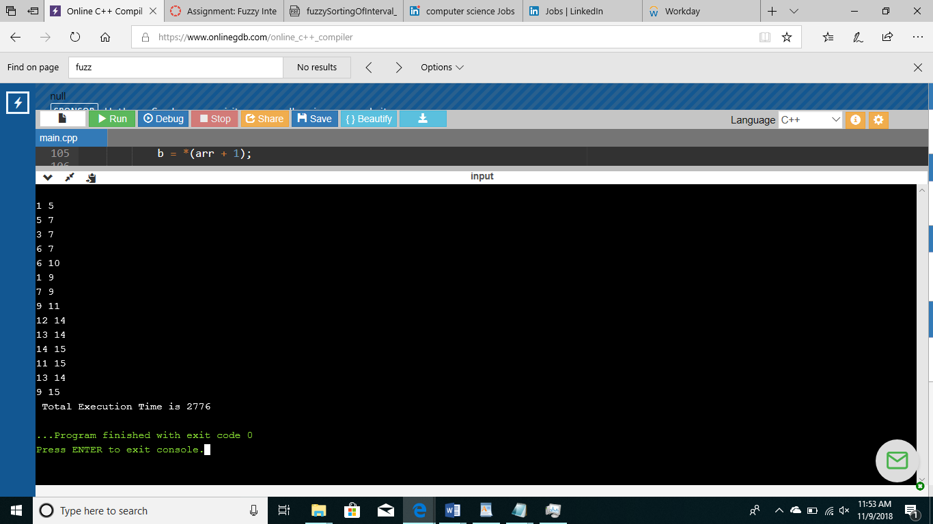

Time Complexity for Fuzzy Complexity

Best Case - O(n)

Average Case - O(nlogn)

Worst Case - O(nlogn)

**CONCLUSION:**

Considering these results, we found out that fuzzy interval sort is more optimal than Quick sort.